

**US Army Corps of Engineers**

**Afghanistan Engineer District**

AED Design Requirements: Hydrology Studies (Provisional)

Various Locations, Afghanistan

January 2010, Version 1.6

**TABLE OF CONTENTS**

AED DESIGN REQUIREMENTS FOR

HYDROLOGY STUDY VARIOUS LOCATIONS, AFGHANISTAN

**Section** Page

**1. General 1**

**2. Hydrology 1**

**3. Design Storm 1**

**4. Runoff Computation Methods 2**

**4.1. Rational Method 2**

**4.2. SCS Unit Hydrograph Method 10**

**5. Design Submittal Documentation 13**

**6. References 14**

**Tables**

Table 1. Runoff Coefficient Values 3

Table 2. Manning’s Channel Roughness Coefficient 9

Table 3. SCS Curve Number for Hydrologic Soil Groups 13

**Figures**

Figure 1. Overland Flow Time of Concentration 6

Figure 2. Shallow Concentrated Flow Velocity 7

Figure 3. SCS Unit Hydrograph Results for 1 Sq Km 11

Figure 4. SCS Soil Classification for Soil Groups 12

**Appendices**

Appendix A Example of Rational Method 17

Appendix B Intensity Duration Frequency Curves 19

Appendix C Area Factor for Point Rainfall Reduction Curves 24

**1. General**

The purpose of this document is to illustrate the technical requirements contractors shall show in design analyses for projects requiring hydrology analysis of storm drainage components that are part of USACE-AED projects. The guidance is provisional – meaning it serves for the time being only until permanently replaced. The development of hydrologic statistics in Afghanistan is an ongoing process and as new data and analyses become available they will be incorporated into this design guide. A companion design guide discusses technical requirements for the design of culverts and road causeways - two hydraulic structures that require hydrologic analysis as the basis of the design.

**2. Hydrology**

Hydrology studies include a careful appraisal of factors affecting storm runoff to insure the development of a drainage system or road crossing culverts are capable of providing the required flow conveyance at the specified annual flood frequency of protection in the contract technical requirements. If the design flood frequency is not specified, the engineer shall base the selection of design storm magnitudes not only on the protection sought but also on the type of construction contemplated and the consequences of storms of greater magnitude than the design storm as specified in References 1 and 9.

Hydrologic studies for USACE-AED projects are generally concerned with the estimate of peak flow rates for use in the hydraulic design of channels, culverts, and erosion control and energy dissipation structures. In limited situations where ponding capacity is required, such as detention or infiltration facilities, runoff volume estimation is required. General USACE design information is provided in Reference 1.

Two hydrologic methods are preferred for use on USACE-AED projects: the Rational Method and the unit hydrograph method. The Rational Method shall be used when the catchment area draining to the structure or other point of concentration is less than one (1) square kilometer (247 acres). The Rational Method is generally limited to the calculation of the peak flow rate. The unit hydrograph method is required for drainage areas greater than one square kilometer. The theory and assumptions involved with these methods are well documented in design manuals and hydrologic engineering texts; two references which can be obtained from U.S. Government internet sources are included in References 2 and 3. The intent of this guide is to provide standardized data and assumptions in the use of these methods to simplify design and review of projects.

**3. Design Conditions**

Ground conditions affecting runoff must be selected to be consistent with existing and anticipated development and also with the characteristics and seasonal time of occurrence of the design rainfall.

Design conditions for the Rational Method consist of the runoff coefficient (C), the rainfall intensity-duration-frequency relationship, and the time of concentration. The runoff coefficient is a single parameter that considers soil type, land use cover (bare, vegetation, or pavement) and slope. There are several sources for C values that are acceptable provided they are accompanied by a complete reference in the design analysis. Generally the more information that is used in the C-value evaluation, the more accurate the flow estimation will be. A suggested chart is included in the next section that has compiled C values from

several references.

In the majority of areas such as military, industrial, and cantonment areas, the design storm will normally be based on rainfall of 10-year frequency. This is equivalent to an annual probability of being equaled or exceeded equal to ten percent each year (Probability=1/10=

0.1, or 10 percent expresses as a percent). Potential damage or operational requirements may warrant a more severe criterion which shall usually be stated in the contract technical

requirements. A lesser criterion may also be employed in regions where storms of an appreciable magnitude are infrequent and either damages or operational capabilities are

such that large expenditures for drainage are not justified. The design of roadway culverts will normally be based on 10-year rainfall. Examples of conditions where greater than 10- year rainfall may be used are areas of steep slope in which overflows would cause severe

erosion damage; high road fills that impound large quantities of water; and primary diversion structures, important bridges, and critical facilities where uninterrupted operation is

imperative.

**4. Runoff Computation Methods**

The design procedures for drainage facilities involve computations to convert the rainfall intensities expected from the design storm into runoff rates which can be used to size the various elements of the storm drainage system. As previously stated, there are two basic approaches: direct estimates of the proportion of the average rainfall intensity which will appear as the peak rate of runoff (Rational Method) and unit hydrograph methods which account for losses such as infiltration and for the effects of flow over the surface to the point of design. The Rational Method approach can be used successfully by experienced designers for drainage areas up to 100 hectares in size and is discussed first. **For watershed sizes greater than one square kilometer a second approach shall be used to compute peak runoff that includes techniques to generate hydrographs, or calculation of a continuous flow rate over time, for surface runoff where studies of large drainage areas or complex conditions of storage require hydrographs are required.**

**4.1. Rational Method**

To compute peak runoff using the Rational Method the following equation is used.

Where

Q=kCIA

Q=peak flow (m3/sec.)

k=0.278 (dimensionless)

C=runoff coefficient (dimensionless) I=rainfall intensity (mm/hr) A=drainage area (km2)

The k value in the above equation is a conversion factor to convert the peak flow into units of m3/second.

a) Runoff Coefficient. The runoff coefficient (C) is a variable of the Rational Method that requires significant judgment and understanding on the part of the designer. The coefficient must account for all the factors affecting the relation of peak flow to average rainfall intensity other than area and response time. A range of C-values is

typically offered to account for slope, condition of cover, soil moisture condition prior to the storm, and other factors that may influence runoff quantities. Good engineering judgment must be used when selecting a C-value for design and peak flow values because a typical coefficient represents the integrated effects of many drainage basin parameters. When available, design and peak flows should be checked against observed flood data. The following discussion considers only the effects of soil groups, land use, and average land slope.

As the slope of the drainage basin increases, the selected C-value should also increase. This is because as the slope of the drainage area increases, the velocity of overland and channel flow will increase, allowing less opportunity for water to infiltrate the ground surface. Thus, more of the rainfall will become runoff from the drainage area. The lowest range of C-values should be used for flat areas where the majority of grades and slopes are less than 2 percent. The average range of C- values should be used for intermediate areas where the majority of grades and slopes range from 2 to 5 percent. The highest range of C-values should be used for steep areas (grades greater than 5 percent), for impervious areas, and for development in clay soil areas.

It is often desirable to develop a composite runoff coefficient based on the percentage of different surface types in the drainage area. The composite procedure can be applied to an entire drainage area or to typical "sample" blocks as a guide to selection of reasonable values of the coefficient for an entire area. Impervious areas such as roadways, need to be accounted for in actual design. An example table of runoff coefficient values is provided Table 1.

Table 1. Runoff Coefficient Values (10-year storm frequency)

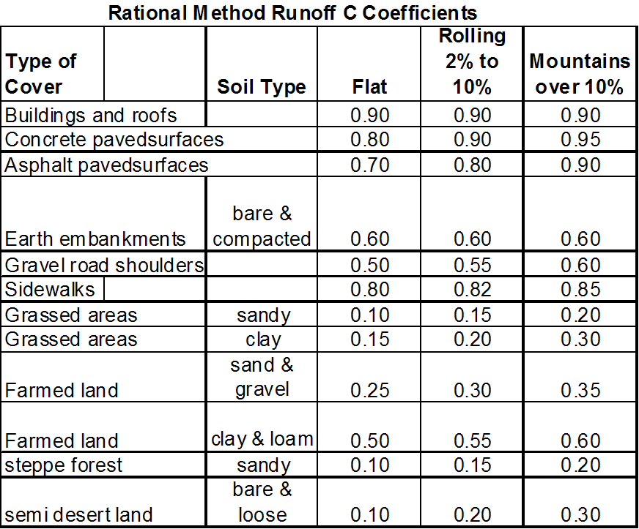

Source: References 7 and 8

Other values that might be more appropriate for specific projects may be used provided they are completely referenced in the design analysis.

b) Rainfall Intensity. The rainfall intensity in millimeters/hour is generally determined from **I**ntensity-**D**uration-**F**requency (IDF) curves, if available. IDF curves are developed for regional areas as opposed to using one value for the entire sections of the country due to the wide fluctuations in rainfall over a large area. Sufficient information is available from sources in Afghanistan that merit the use of local data rather than attempts to derive IDF relationships from other countries. Data obtained from The Ministry of Energy and Water (MEW). The data was developed into IDF curves shown in Appendix B. The curves were developed as follows:

• Maximum annual 24-hour rainfall total depth measurements were compiled and fit to the Log Pearson Type III probability distribution using the Corps of Engineers computer program FFA (Reference 4); 10-, 20- , and 50- year 24- hour peak rainfall intensities were calculated

• The peak 24-hour intensities for each frequency were multiplied by ratios to obtain hour, one-hour, 30-minute, and 15 minute rainfall intensities for each time duration. The ratios were based on regional rainfall intensity durations curves obtained from MEW.

• The calculated rainfall intensity data were plotted on charts using log-log abscissa and ordinate scales

In regions where no I-D-F curve is available, the rainfall intensity may be calculated by the following formula:

I=(R/24)*(24/Tc) K

Where

I=rainfall intensity (mm/hr)

R=maximum daily rainfall for design frequency (mm) Tc=time of concentration (hr)

K = a regional coefficient whose approximate value is 0.722 for Afghanistan for 10-

year storm

c) Time of Concentration. Time of concentration is the time for runoff to travel from the most hydraulically distant point in the watershed to the point of interest within the watershed. The time of concentration is the sum of the overland flow time, the shallow concentrated flow time and the channel flow time. For almost all drainage areas the maximum length of the overland flow will be approximately 100 meters. Overland flow will normally occur at the upper ends of the drainage or installation catchment area and will occur over relatively smooth surfaces such as parking areas and flat slopes. In areas where shallow ditches occur, the runoff will not be overland flow but will concentrate into shallow channels. Farther downstream the shallow channels such as gutters and surface swales further concentrate into open channel drainages. The following figure illustrates the concept of these flow components.

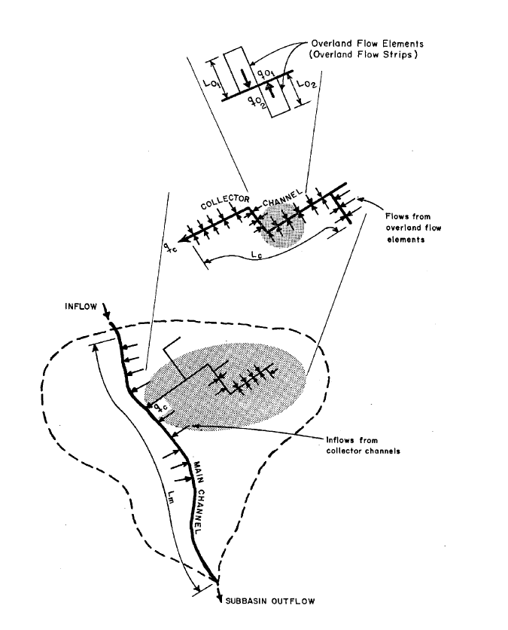

Source: Reference 3.

The overland flow time of concentration may be determined by the following nomograph in Figure 1. A nomograph is a chart usually containing three parallel scales graduated for different variables so that when a straight line connects values of any two, the related value may be read directly from the third at the point intersected by the line. Notice that the units on this nomograph are U.S. customary units and the result should be obtained first in this unit system and converted to SI units because the nomograph is based on the equation shown on it that uses empirical constants developed in this unit system.

Figure 1. Nomograph for Overland Flow Time of Concentration

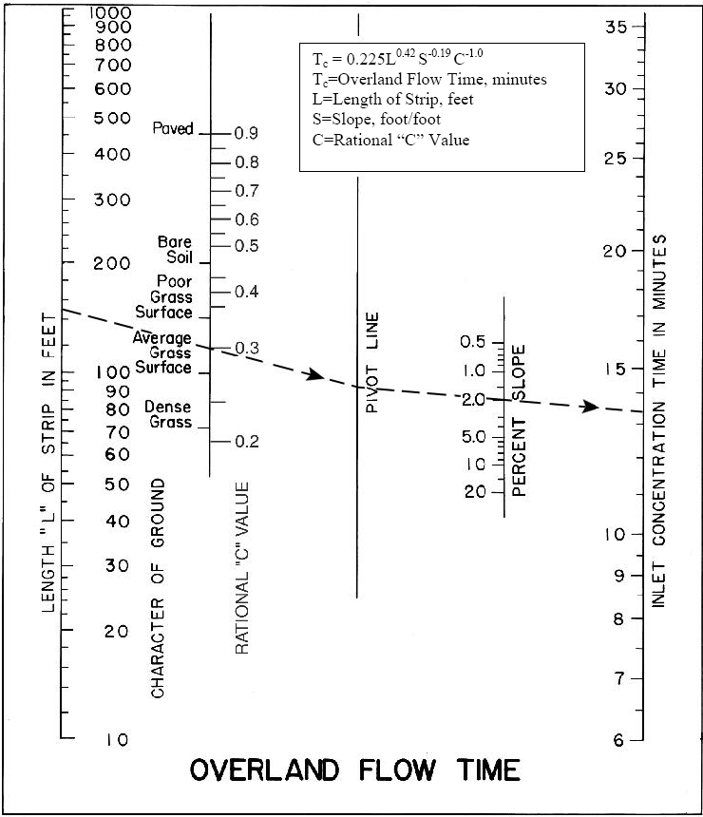

The overland flow time of concentration is determined by drawing a straight line through the flow length of the overland flow and the surface type or rational runoff coefficient and extending this line to the pivot line in the center of the nomograph. A line is then drawn from the intersecting point of the first line and the pivot line through the overland flow slope and extending this line to the concentration time line. Alternately the equation given in the top of Figure 1 can be used to calculate the time of concentration.

Shallow concentrated flow will occur after the maximum length of overland flow; generally within a distance of 100 to 150 meters such as in the depressions on the side of a slope or mountain. The designer should use topographic maps to determine where the shallow concentrated flow will begin and end such as a shallow watercourse. Topographic maps can be obtained from project survey drawings or for areas not within the project limits from Reference 6. The map scale for Afghanistan topographic maps is 1:250,000, and therefore will generally be used in conjunction with a CAD program to enlarge, scale and compute the area from an image file.

Shallow concentrated flow time of concentration is determined by dividing the flow length by the flow velocity. The flow velocity is determined by the following nomograph:

Figure 2. Nomograph for Shallow Concentrated Flow Velocity

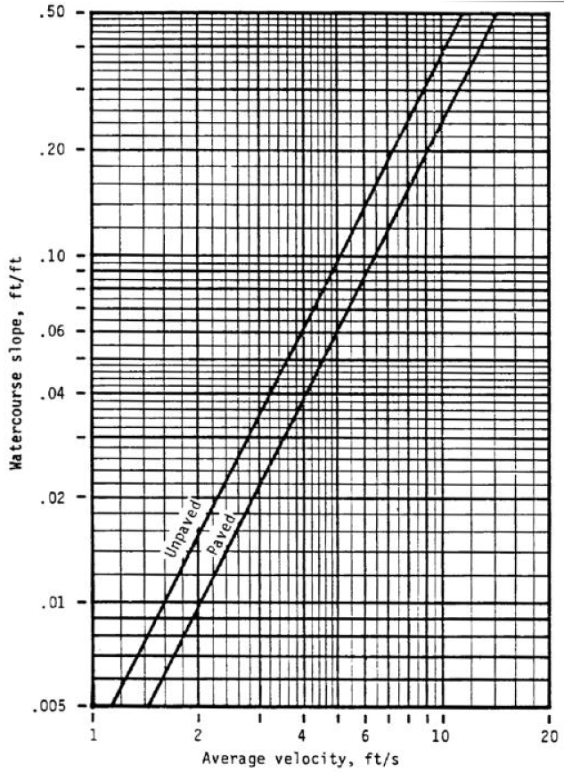

Enter the nomograph using the slope of the shallow concentrated flow path and extend a line horizontally until the diagonal line of the appropriate surface type is intersected. From this point, extend the line straight down to determine the average velocity. The average velocity of the above nomograph is expressed in ft/sec. which is converted to m/min by multiplying by 18.29. The equations for these surfaces are:

|  |  |  |  |
| --- | --- | --- | --- |
| Unpaved surface: | y = 16.441 * x0.5063 | where: | x = slope, ft/ft |
| Paved surface: | y = 19.794 * x0.4896 |  | y = average velocity, ft/s |

Total time of concentration (T) is the sum of the overland and shallow travel time (To), plus the concentrated channel travel time (Tc), if any. An example is provided showing the steps necessary to calculate T using the previous concepts and equations.

Channel flow will occur in swales, ditches or underground culverts that have a sufficient volume to adequately convey the flow. Channel flow time of concentration is determined by dividing the flow length by the flow velocity. The channel flow velocity is determined by Manning’s formula as shown below.

V = 1.0 * R2/3 * S1/2 n = roughness coefficient V = 1.49 * R2/3 * S1/2

n R = hydraulic radius, cross n

V = flow velocity (m/sec) sectional flow area/wetted V = flow velocity (ft/sec)

perimeter

S = channel slope (m/m)

Manning’s roughness coefficients (n) for channel surfaces are provided below in Table 2. When designing channels for drainage collection and conveyance, stone or concrete lined

trapezoidal channels with 120 degree interior angles are strongly recommended since they are compact, and can collect and efficiently convey significant quantities of water. Earthen

swales with side slopes of 3 Horizontal to 1 Vertical may be used in flat areas, but these channels erode quickly when subject to high flows. Channels on AED projects shall be lined

and trapezoidal when possible. Channel design and safety factors are described below.

Size channels in the following manner: Calculate the required flow area. Add a safety factor of 33% to both the horizontal and vertical channel dimensions to allow for sediment buildup and trash in the bottom. Add an additional 150mm freeboard height to the channel configuration which already includes the safety factor. More freeboard may be required at bends in the collection system.

Channels shall not make sharp 90 degree bends, but shall have smooth curves for turns. Conveyance systems with combinations of channels and culverts shall provide equal flow area for both styles of conveyance to prevent creating flow restrictions and potential flooding. Energy dissipation devices shall be provided where grades create high velocities. Where a 90 degree bend cannot be avoided due to site constraints, a covered, manhole type structure may be necessary to prevent spillage out of the channel.

**NOTE: Even though flow calculations may indicate that smaller channels will adequately convey flows, the smallest channel allowed on AED projects shall have a bottom width of 400mm and a side height of 400mm. Final channel configuration shall include the required flow area plus the 33% safety factor plus the required freeboard.**

**Table 2. Manning's Channel Roughness Coefficient**

Type of Channel andDescription **Minimum** Normal

LINED CHANNELS (Selected lmings)

a. Concrete

1. Trowelf nish 0.011 0.013

2. Floatf nish 0.013 0.015

3. Gunite, good section 0.016 0.019 b. Asphalt

1. Smooth 0.013 0.013

2. Roug111 0.016 0.016

EXCAVATEDOR DREDGED

a.Earth, straight and unifoml

1.Clean, recently completed 0.016 0.018

2. Clean, after weathering 0.018 0.022

3.Gravel,uniformsection, dean 0.022 0.025

4.With short grass, few weeds 0.022 0.027 b.Earth,winding and sluggish

1.No vegetation 0.023 0.025

**2. Grass, some weeds** 0.025 0.030

3.Dense weeds or aquatic plants in deep channels 0.030 0.035

4.Earth bottomand rubble sides 0.025 0.030

5.Stony!bottomand weedy sides 0.025 0.035

6.Cobble bottom and clean sides 0.030 0.040

c.Dragline excavated or dredged

1.No vegetation 0.025 0.028

2.Light brush on banKs 0.035 0.050 d.Rock cuts

1.Smooth and uniform 0.025 0.035

2.Jagged and irregular 0.035 0.040

e. Channels not maintained,weedsand brush uncut

1.Dense- weeds,high as flow depth 0.050 0.080

2. CleanIIJottom, brush on sides 0.040 0.050

3.Same, highest stage of flow 0.045 0.070

4.Densebrush, high stage 0.080 0.100

Max nwm

0.015

0.016

0.023

0.020

0.025

0.030

0.033

0.030

0.033

0.040

0.035

0.045

0.050

0.033

0.060

0.040

0.050

0.120

0.080

0.110

0.140

NATURAL STREAMS

1. Minor streams (top width at flood stage <100ft)

a. Streams on Plain

1. Clean, straight, full stage,

no lifts or deep pools 0.025 0.030 0.033

2. Same as above, but more stones/weeds 0.030 0.035 0.040

3. Clean,winding,somepools/shoals 0.033 0.040 0.045

4. Same as above, but some weeds/stones 0.035 0.045 0.050

5. Same as above, lower stages,

more ineffective slopes and sections 0.040 0.048 0.055

6. Same as 4,IJut mae stones 0.045 0.050 0.060

7. Sluggish reaches,weedy,deep pools 0.050 0.070 0.080

8. *Very* weedy reaches,deeppools,or ftoodways with heavy stand of timiJer

and undertJrush 0.075 0.100 0.150 b.Mountain streams,no vegetation in channel,

IJanks usually steep,trees and brush along banKs submerged at high stages

|  |  |  |  |  |
| --- | --- | --- | --- | --- |
| 1. | Bottom:gravels, cob!Jies and few | 0.030 | 0.040 | 0.050 |
| 2. | boulders  Bottom: oobbles with large boulders | 0.040 | 0.050 | 0.070 |

2.Floodplains

a. Pasture, no IJrush

1.Short grass 0.025 0.030 0.035

2.High grass 0.030 0.035 0.050

b. Cultivated area

1.No crop 0.020 0.030 0.040

2.Mature now crops 0.025 0.035 0.045

3.Mature field crops 0.030 0.040 0.050

c. Brush

1.Scattered brush,heavy weeds 0.035 0.050 0.070

2.Light brush and trees,in winter 0.035 0.050 0.060

3.Light brushand trees, insummer 0.040 0.060 0.080

4.Medium to dense brush, in winter 0.045 0.070 0.110

5.Medium to dense brush, in summer 0.700 0.100 0.160

d. Trees

1.Dense Willows,summer,straigllt 0.110 0.150 0.200

2.aeared land " ithtree stumps,no

sprouts 0.030 0.040 0.050

3. Same as above,but ith heavy

growth of sprouts 0.050 0.060 0.080

4.Heavy stand of t mber,a few down

trees, lrttteundergro·1.h,flood stage

IJelow !>ranches 0.080 0.100 0.120

5.Same as above, butwithflood stage 0.100 0.120 0.160 reaching branches

3. Major Streams (top width at flood stage > 100 ft)

The n value is less than that for minor streams of similar description,IJecause banKs offer tess effective resistance.

|  |  |  |
| --- | --- | --- |
| a. Regular section with no boulders or IJrush | 0.025 | 0.060 |
| b.Irregular and rough section | 0.035 | 0.100 |

Several alternative methods are available for estimation of the time of concentration that are based on empirical relationships for specific geographic areas and caution should be exerted in their application to a specific site. For example, another method for overland time of concentration is Kirpich’s formula. It is based on analysis of data for watersheds in the state of Tennessee in the United States and has not been validated for Afghanistan. Note the units are customary US units are used in some of these methods which should be used to provide the results because the formula is based on empirical coefficients derived in that unit system.

**4.2. Soil Conservation Service (SCS) Unit Hydrograph Method**

As the drainage basin size increases, the Rational Method becomes less accurate for a number of reasons. The principal reason is that the underlying concept behind the method, namely that the peak rainfall intensity duration is equal to the time of concentration no longer is a reasonable assumption. The water courses in larger basins have flood plains that will reduce larger flood flow rates because they will store flood water in their overbank areas thereby reducing the peak discharge rate. Large basins have more varied topography which correlates to varying times of concentration. Because of these and other limitations, numerous methods for developing unit hydrographs for selected watersheds have developed. **The Rational Method may significantly overestimate the peak discharge rate for larger basins and therefore the limit of 1 square kilometer for it has evolved from engineering experience as a useful upper limit.**

A unit hydrograph is defined as the direct runoff hydrograph (flow rate versus time relationship) from one unit of excess rainfall (usually 1 cm in SI units) generated uniformly over the drainage area at a constant rate for an effective duration of time. References 2 and 3 provide information on the theory and calculation details.

Because the solution to the total hydrograph computation involves successive convolutions of unit hydrographs for the period of the storm, the method is suitable to the use of computer programs for execution. Several programs are available from US Government agencies that are based on a particular unit hydrograph shape known as the SCS unit dimensionless hydrograph; reference 3 shows the location for one such program HEC-1 Flood hydrograph package. This program allows the user to employ the SCS unit hydrograph method with a hypothetical rainfall pattern constructed from data obtained from the intensity-duration- frequency curves (previously described in the rational method) to compute runoff hydrographs. In order to simplify the use of the SCS method for drainage areas in the range of one to two square kilometers which are common on road projects in Afghanistan, graphs have been prepared of peak discharge and runoff volumes have been computed for use shown in Figure 3. Results for other basins sizes can be obtained by the ratio of the drainage areas multiplied times the values from the figure. For large basins (greater than 10 sq km) a factor shown in Appendix C may be applicable.

Figure 3. SCS Unit Hydrograph Results for 1 Sq Km Drainage Area

**SCS Unit Hydrograph Runoff Results For 1 Sq Km**

8

7

6

**Peak 10-year Flood Flow, cms**

CN = 95 & RUNOFF = 75% of RAINFALL

5

CN = 95 & RUNOFF = 20% of RAINFALL

4

3 CN = 85 & RUNOFF = 40% of RAINFALL

2

CN = 75 & RUNOFF = 20% of RAINFALL

1

0

0.5 0.7 0.9 1.1 1.3 1.5 1.7

**Basin Lag Time, hours**

Peak, cms Peak, cms

Caution should be used applying data in Figure 3 for basins greater than two square kilometers in size because the floodplain attenuation effects in larger watersheds are neglected. Use of the curves requires calculating the basin lag defined as 0.6 times the time of concentration and the approximate runoff ratio based on the rational method or from data to develop curve numbers described below. For basins larger than 2 square kilometers or other flood frequency (than 10-year) storms, the design should be based on calculating the runoff using a computer model that supports the SCS method. If more than one basin analysis is required, a computer model should be used to perform hydrologic routing of the individual basins; Figure 3 curves do not include these affects and should not be used to combine more than one basin results.

The SCS unit hydrograph technique is described in reference 2. There are two basic parameters required to use this method: basin lag and basin runoff curve number (CN) value. Basin lag is defined by the method as approximately 0.6 times the time of concentration (previously described in the rational method). The curve number is a dimensionless number that is an empirical function of soils slope, and land cover. It is used in the SCS method to determine the amount of rainfall retention over time that the watershed can hold. The excess becomes runoff. The curve numbers were derived empirically for non urban areas in the United States following a long program of collecting measurements at Soil Conservation Service hydrologic field stations of stream flow, precipitation, land cover and soil moisture. Tables of CN values for different hydrologic soil

groups and land use are published in several sources. Soil types are defined as follows:

Group A: deep sands, deep loess, aggregated silts

Group B: shallow loess, sandy loam

Group C: clay loams, shallow sandy loams, and soils high in clay

Group D: soils that swell when wet, plastic clays, and certain saline soils

Soil classification is defined in the SCS soil classification textural triangle shown in Figure 4. The availability of soil classification in regions of Afghanistan can be determined using internet sources (see References 5 and 6). Surface soil classification from geotechnical reports for project foundation design can also be used as a source of soil information provided the top soil horizon is used for determination of the runoff curve number.

Figure 4. SCS Soil Classification for Soil Groups

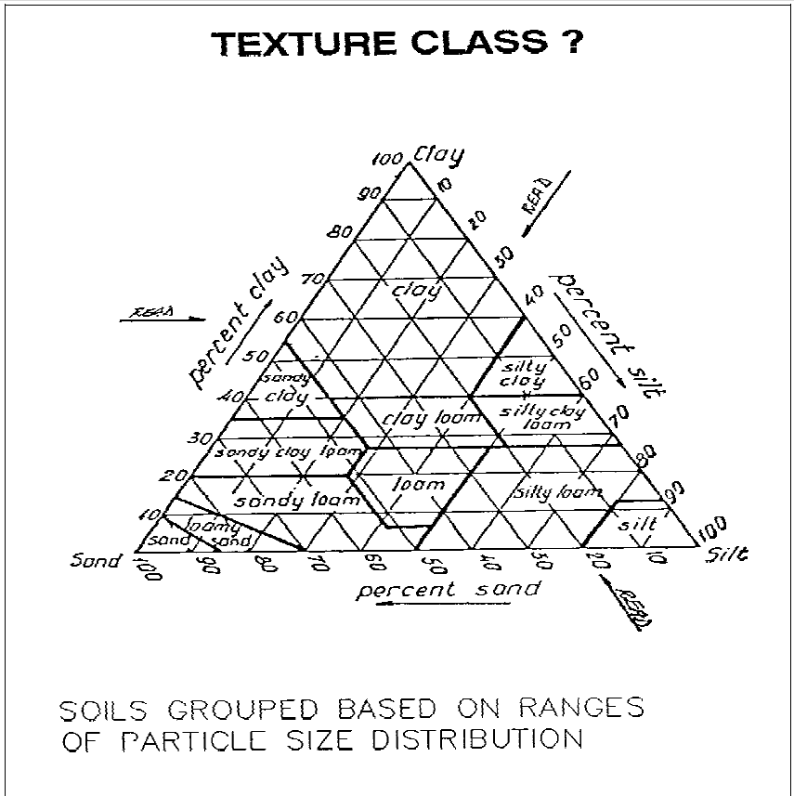

The following Table 3 contains an example from Reference 2 of curve number values.

Table 3. SCS Curve Number for Hydrologic Soil Groups

T"'*H

Runoft CN'e lor Hy*ologlc Soil-Co,... Com!Mll"

(An-.dent rvnolf condition II, . . d .. • 0.2S)

|  |  |  |  |  |  |  |
| --- | --- | --- | --- | --- | --- | --- |
| eo..., | | | Soil Group | | | |
| lalduse | Treelment or practice | Hydrologic  Condition | A | B | c | 0 |
| Fallaw | Su.igl\t row |  | 77 | 86 | 9\ | 94 |
| Row crops | Stnlight row  Contoorad  Corrtoorad and tllfl'llC8d | Poor Good Poor Good Poor Good | 72  67  70  65  66  62 | 81  78  79  75  7(  71 | 88  85  82  80  78 | 91  89  $8  86  82  81 |
| Sm•l  grain | Sttaighl row  Corrtourad  Contoored and len'aced | Poor Good Poor  Good  Poor  Good | 65  63  63  61  61  59 | 76  75  74  73  72  70 | 83  82  81  79  78 | &a  87  as  &4  82  81 |
| Close·seeded lagume61  or rotation meadow | Straight row  Contoorad  Contoured and ten"aced | Poor *Good* Poor *Good* Poor Good | 66  58  64  55  63  51 | *11*  72  75  69  73  67 | 85  81  83  78  80  76 | 89  8$  85  83  83  80 |
| Pasture or rang9 | Contoured | Poor Fair *Good* Poor Fair Good | 68  49  39  47  25  6 | 79  69  61  67  59  35 | 86  79  74  81  75  70 | 89  84  80  $8  83  79 |
| M&adow |  | Good | 30 | 58 | 71 | 7$ |
| Woods |  | Poor Fair Good | 45  36  25 | 66  60  55 | 77  73  70 | 83  79  *n* |
| Farrnst&ads |  |  | 59 | 74 | 82 | 86 |
|  | |
| Roads (di115 *)2*  (hard sutface)2 |  |  | 72  74 | 82  84 | 87  90 | 89  92 |

1 Closed-drilled or broadcasl

*2* lnclud"\1 riQht-of-way.

**5. Design Submittal Documentation**

Design analysis reports shall summarize the results of the calculations in a tabular form. The contents of the table shall include the following information:

• basin name/ or culvert number

• drainage area

• calculated time of concentration

• rainfall intensity for design storm

• runoff coefficient in rational method for the basin

• reduction for total area factor

• peak flow rate at the point of concentration (for structure design)

• channel sizing calculations showing equations used, assumptions, Manning coefficients, channel dimensions including sketches with bottom, side and freeboard dimensions, slopes, velocities, maximum capacities and anticipated conveyance due to site-specific storm requirements.

Submittal shall include drawings or sketches that identify the catchments areas used n the calculations.

**6. References**

1. UFC 3 230 17FA Drainage for Areas Other than Airfields. Department of Defense, January 2004.

2. U.S. Army Corps of Engineers. Engineering and Design Flood hydrograph Analysis, EM 110-2-1417, August 1994. Found at

<http://140.194.76.129/publications/eng-manuals/em1110-2-1417/toc.htm>

3. U.S. Army Corps of Engineers, Hydrologic Engineering Center, HEC-1 Flood Hydrograph Package. 1998. Found at <http://www.hec.usace.army.mil/software/legacysoftware/hec1/hec1.htm>

4. U.S. Army Corps of Engineers, Hydrologic Engineering Center, Flood Frequency

Analysis (FFA) Program. 1994.

5. European Commission Land Management & Natrual Hazards Unit. Found at <http://eusoils.jrc.ec.europa.eu/result.cfm?form.criteria=afghanistan%20and%20soil>

6. US Geological Survey Open-File Report 2005-1103 Series of topographic maps found at

<http://pubs.usgs.gov/of/2005/>

7. Civil Engineering Reference Manual, Michael Lindenburg, Profesional Publications, Inc. 2008

8. Washington State Department of Transportation, Hydraulics Manual, March 2005.

Found at <http://www.wsdot.wa.gov/Design/Hydraulics/>

9. UFC 3 230 15FA Surface Drainage Facilities for Airfields and Heliports. Department

of Defense, January 2004.

Topographic Map Index Information for

,.. - <. ,

USGS Afghanistan Topographic Maps

The U.S Geologica] Survey (USGS) hasusedTNTmip$ lO pre­ pare a sertes of32 topOitraphic mlp.!l of Afghanislan a1 1scaJe. of 1:2.50,000, in cooperation w1th lhc Afghun Qe.ological Sur· vey and Af}!r:tanliuan Ot:l)de))' a1ulCu.•'LU1tf11ph)' Heud Vfnce. These maps pi'Qvidc complclc 0\'Cro.au oflhe country and are published electronic-ally in the USGS Open File Report 5cries as PDF map fiJes that can be prlnt.td to seal. Etch map co\·crs

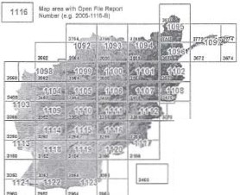

a quadrangle 1° bttwdc: by 2" lon&Jtutlin sib!, or portions of

Soe'l.enl quadrangles aJong chc border of the country.lhc:com­

plete rr.ap I'C'ferc:oces are IIJkd on the I'C\Cf1C $1dt ofdtis pa:;c

aloag,.ilhadownJood look.....tlhe ondc•111119 10doe rill>•sbo..s

,A ­ ,

dtmap areasv.icb rcpon numbtn.. Acompankln .mesof geo­ losk m>ps bos also bo= publisbe<l (- lhe TedmH:al Gcide entilled *USGS#ghmwtan G<olqgo< -""PP*

no. map coropiJ<n at lhe USOS U>Cd lhe SwfOOC< Mod<llllg proce'"..:; m Th'Tm1p;o; t.o c<:oorat.o \QpOJ:,..,h.lc oontourJ *(OT* the maps from Shmtlc Radar TopoJr.oph) Mission (SRT\1) 85-m digitAl elevation dat.a. The eontoun ate overlaid on a color

$h3dM·reliefimage alsoderived from the SRTM data t.Jing lhc

niTSlope,Asp«:Shadong"""'"''(now Lho'IOp<Jal1lphic Prop­ ies process). The: &ream lines l!ltl) selected now pt!th lines gen unted from the SRTM data. U5ina, the Tht'fmips Watershed

U!.Q :S 2SQtiOC

....,.,..,.,

f<;/111 . .1 *'*.a"c'*·f't

*...........t)*

process. This prOOC$5 automatiClllly generales stream order at· uibuteS for lhe 00W p3tll.J lnd I selection quoy On t he JfonOil stn:am order val\te wu u..cd to cxtl'lt:t•n appropriate dcnsily or s.tream lines for each map. (over)

1

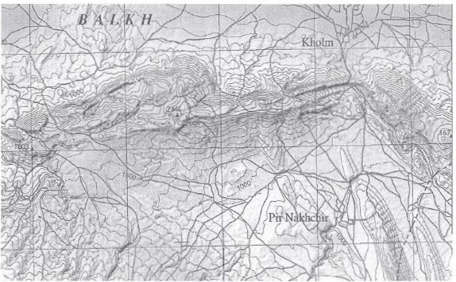

Po<ticn ofT*Mop of* a.-o¥os 3SU-3761 *8aJid> {219).IMzar.f Siuod {2201* Qonoo<o 11131 *wd kn.,.*T*{214)*

Ovadratl¢es. A.7'US Geologal S\lrwy Open F-. Repon 2:00S-10Slo-9 CC1f!11I>)' Robert G BohaT'II!Cift. ExtraaIs

sho-IIN'n atpltluned seaor 1 000

Moaolma;es.lnc. • IIChHoor·Sh:arpTo"'cr • 106Sourb lltbS!reet • Unoon. cht'l!la • 63SOS.J010 ·US.-\

\lnce (402H77·95S4 • fAX l4fU)ol77..tSS9 • al mfo@m om • \\ocll \'lv.wmk.'fl-!m.sc:oM • J me 2007

Hydrology Stucty

All of the 32 AfghanistanTopographic maps listed below are availabel for free download •• POF filos from: bttp:J/pubs.usas.goy/of/2005. Seethe Index map on the reverse side of this page for locations.

*·,.<f J:.J...t_....,._/117)..,._..(11fl.*

*"'• (11JJ...JSiw"'"'""'IIUJ>.* us

0.. 1111 ::>......, 0.,..:,• fol" Z005·1 ·8, cumpilc:G *In'* m 0

&......

*Jll'a,lfhlr:* AJa;l*nf@mt#HmJJI"' M*"""i'*76 .ll (1IP).J.IGI 'It.vJ{*

*(210),rpqr.mJ),..J H"""" ll>si"' m<Jg. ,Afgllvnut...* u.s

Oooloclcat ey Opal file 200·109-l-8, Comj!Ucd b) Rubert G

A.: tww.on..

*T--U·<( t'<•-'.U...-(1/JI­*

u•­

*(2/0J.&cloJ-(111)...T.......(2}1/ ,w..-*

loJI...-1 - 0;1a1 F'lk Jt.r-pon :OOS...I -8. COQjMied II) Ratcn 0

Sllf'q

""" """

*T ltt-t.M.:po/0-JI JI!()-.JJT7Q. t,t.Q(111)• ./u.WIU/f'I-*

*TJl.>pf{ gV ad""·'""""'*f{(/wtftttl< *JJlO. .kkJ..AW (J/1). ISI1J, atd lo'(lf"llttMINII Aljl-- f'Jl) .AJI!W'IIIl.t,.* tJ_.:._ UCOIOp;ll :r,unC)' I'lie Repllrt

lOI)S..J J!IS..IJ.cx. mr•loJ b)·llobcn G.B«lar.ooo.

*T"""""""'k>t.p<if MI*!J*,.*S*.*.*5/ofn.Donl(I* JJ*oood* Tlfl>t*(16)(/oo<fo n111;.4$. I'JII,* U.S (l.."'()f<ltlcat Sur..-.:y Open Flit:R.epon 2005-1109-8, c:ompi[cd by Robc:n0. (lo

*T W.<( JJ61. -.e..d(J/7Jr.l-(ll!/*

*-.....*U3 SclrYCf'()pcltf*lqo..'ll'l 111D-ll.

. .... .lo }ll oi>MG-

r_.,.,....

.,fJ-lo-r/#*UU.G.,.(Sf }I ... - tSU/* Q>W.

S

*...,ta.A* ()oeloso<oiS....,.Opcofile.......lOOl•llll-8.

0

wmpikd.by

Rotxn

&ollaMOo.

*Sa/4(211/. F¢·.<1od(211),...11-(118) s.Afg/lvn'<""'*

US Cirolopcal SUI\'q'a hk K<tpon 200S-109S-B, oompt.lcd by Rob..'ft

a Dohtuu:(ln.

r.,..,.,A;, *"" 'c/ 1•151o Jono·K""=1113) a.JZ.!.!m•J*

*.!.J-* A;tbl#ilft,US j.;ol $un-cy O?ca File Rqon 200 ·

109 8.-<db)'lloi>MG8dlm..­

14;:lo4'J11.4 *ffll* J6:"2 *alfiiiJ671,c;..n-(JJJ'I.*

*WIJIJI U.U'* J :&.IJU *.o.:-ld(JI9J.lit (J\**

..._s.n.,

*..,.IWllofl111e-t-.b.w---* u.s. OpaiFil<

lttpM lOOS-109?-B,C'Ompdat R.r;)bm G '9ob:IDnoD.

'TbpDff'fl/lk *Mop cf tu* JJ. *JJ61. and 36Q, Sv 80114 (1'1:;. K'-io.J"(ID!).Ji.IJ.M.,..;..b (JOJ/ #Wl /Wa/N l·K4'"""'""(112) QlflldrrN!g.W.t,..4fg"o.ttbta"" US* O.vl J!o:lll SW'\>ey()pen File Rcporl 2<lOS

10980·,Cllf!lp!l¢d by Robc:rl 0. 0()ll.ltlnon

*Tlljll)f"fJp}tK.\fJPafJJ64 OdtrM1tl<xmd) I40JJUifiJG nJW<M (1114/* u• -cyO,..fok ...... lOGS-I (199.8.,con;*d.,Rokl\c.i Bolslnao&-

,_....,.... . )64 *ISO/} _,,.,.....0.* K.-fli'J]/ .-.·- u.s GcoloP"'s.n.., 0pa1r•• R4111*tl00l1 B. c:GIQJidt41!r A.Mt-11 *r.* Ato'lwmlwl

,)

*.1/Qpqf 'fl•*JJ6.1 "*-"*(SOJJao<dC/wD(W)*

*Topographic Mop QjO o fiJ 16$tJifd1Wt of(}vadr..,t*JJ*TO. GM: t (J IJ),Wnir.($ /6), tWi PuntQ.kgi-Maydtm(317)*{.?rml*"'l,fl'U,l({.sMtfJ.lftefl. U S.Geoaogical Sur-.'e)' ()pee hie Repc:n 2005•1 J I 2-U, comI"'!led by Robcrl

Glloluuoooo.

*T U.t( J1JfOf*dJI60.o..At.£..cNitc J.t.r.,(Jif)*

._.. *(111!; -MI/.ood (1111)* .w-o­

U.S.S.,n()pal File- Jtcpon 200S.ll J).8.W II) l':abcn

(l--

r *ldap fl/t JJ61. F.w!t ft:IJ* ottd *1/IIA,..·E.J>w.. (422) Qsladr.,fltl.-t{,UWt:m.* U.s Cieoiosical ()peaFile Jtepon 200:)..) IJ4-B.comotled lw Rtlbc:ri Q Bohanmn

*T tc.Wapr( &J JlM, }.'tN':4d·M (I11).,.:1 Mttt.lw*

*(IU)Quodrollfllu.*l(;i:h; "ttl<ln. U.S. Oeolog.:.:tl unqo (:)rtn fe Rqwxt

2005·111 >·9, compiled by Robert Q Oclbmoee.

*T"'PYY!:·44't f J11d. (JI91andM>qWJJ111i*

*d*\1$.0ooqlal$cn '()pmFif-eft.lpx1 ·lli B,.

b)-..G-

*T .U:.,t/Qaaf #t"ZJIMOitll.iNl W,.lf'...,(7DJJ* Qwsd

*1'011.Kkrr.X.!J11J,oodU...,.m2J ,.,..__* u.c;...

lOs_leal ttu1wy vroc-n tilt Ktport .".UO!I lii 7 H, com,•k'A b) Jlobert G.

""""'

*kl,<ifghwu.r:.m.* U.S Oc:oloa:te:al Survey ()pcB f'ik Report 1005· *TMap ofQ-/r;Jngk J/62,ChttAharl.wr(6QJ) tJtUI Kot:MDA (601)*

1101·8.compdtdby RobcrtO.ll<ltt.e:nnon..

*hit* !t!o;J *Dj It* JJ*14. Tlf#flb-E M:MrfJ!JIJ (JOJJ and Al111.,..* I(.,..VI *(JM)* #........"' US. Geoq;cS""'l'0,..Fol• Rtron too.S..Il02-a..<:C Cplltd Rcttut Q &bai:Doa.

*T,...,.....W Jkp* </*Ulil_,J16b K.UJI-*-(J/11/.*

*(( IIJJ ..-1Xlflw- U* c : f .. *(4/IJ*

*·.w--*

u.s Go>lvpaiS...,Opalri<--­

*Q.uadrt tS I I,* Afg/ti»lMhl"- \l.S, Ucclo;;SUI'\·cy ()pen ftlc Rcpon 200­!

lliSB· .compiled by Robcn0.8o.lllllttlll)a

*r,.....,.. M.,.tQo.""""PJ/61. :<u !6bJJ"""t:.NkJw MJ*

*' w -*

u.s s.....,.,... fok ..,..200>

111 -"rR_G_

.,.,...,.-....*w.*.,*1166. .RJJ:; (71)/*0*J*p*_*a*.*·1"r'"•'·•'.".",".'*"*..-*"*.

IIOl-11."""'*"II}Robert Q -

112G--B.

u

Rnbcn0

Geol<>ciool s.n-c,·

ClOe'npik4 b)

Boblmor&.

*C A/t:lp Q/t 1161 Jkral/409) r:ndc;ksht-$1t.'W({(II0)*

*(}l.odtQ.Itffu, .ittat1.* U.S Oevl.:-Sur.-cy ()pcB FiJc Rqlon lOOS·

I I04·8, compi!cd by Robert0. OobllriDOI\

*ll>poJlNP,.,Map•f.JIH S..,_(Jll)•wllWI(I/2)(/...J•*

*1\'itu,*·U $.<ltolop:al ''"'11)'0pc:nfik Rqlon2005·lllt5·0,

C(lmfd.:J by RobmG &II_.'"

*,...........,......<(- /.MS.;o.,JM1)...........1JI1f)*

*T .IC Moptf tkl J060 atfd 2960. Q:Jio-1·""'" (t.rA•t)* llaki.

*Saj·lt·Kdl (6/J). Ofld(;o:;r.(614) Quodtv,mgl¥.M!hiiY!Iltalt* U.S

Geol0£etaf $tuYcy Open file Repon l:OOS·It21-B. cw•"'llcd by R'*rt G

o........

*T MJp<f •lM1ondl961.Cioa...,.. O,,* Kiwlow<""'

*/O).GJwdi:m/<(6/jJ."*'-16161 >.*U.S

-.a

Geolo-.,kol S""<y()p<o f'ok ..,.,..liJOS.IIlUI. _..... "r

1106-B."""'*".,.-U..aS .-....,_C.Fok-200:1·

'""'"""'*>r.p<fk* #I<Ju< *._.,.,..oi(Sl)9/wo/K4!wl*

-1

*200H* 11)1.8, oompil<d b)' (l""'"""""·

*T*"""""""'

*.qf JIJiJ. JM4--106<./A>B-*'*

*(JID)* ('"-. *A//Jtimillon.* U S <ieol•Sun-ey Open F1lc fl et

*(Ill).*.Jah-:ro.pT>-\.nwN!f *(ti1J.* Srdt-Chn4 *(l01}.1NJJr61T),*

*Af (616J.*G'ld$oaloiii'PI!IA<M .J..Drto!'*(1J3J(JM.:JJrtrr:dv, A UI'OI't* U.S_

!iO)IODQI SUI'I<Y Open fil< R<pon 21101·11l3.B, <ompded by Rob<n G.

nc.ohxmon.

\IMulmu}:io,IM • ll lh fioof-StwpT0\4-'Cr • l06SouU.1131hStm:t • Lincoln. /'11 )... lUlU • USA

ioe:(40Z)of;77- S4. FAX(<I02)o&7MS$9.caul illborJDt. YI'Cb .,.,.,...JtJnC2007

**Appendix A Example of Rational Method**

A site review for a road project in Nuristan Province has determined that a culvert should be designed based on the ten-year storm peak flow using the rational method. The location of the project is shown on a topographic map obtained from the internet site listed in reference 6. The web site was used to obtain a photograph that shows the ground cover conditions. These are shown below:

Drainage area map determined using AutoCAD

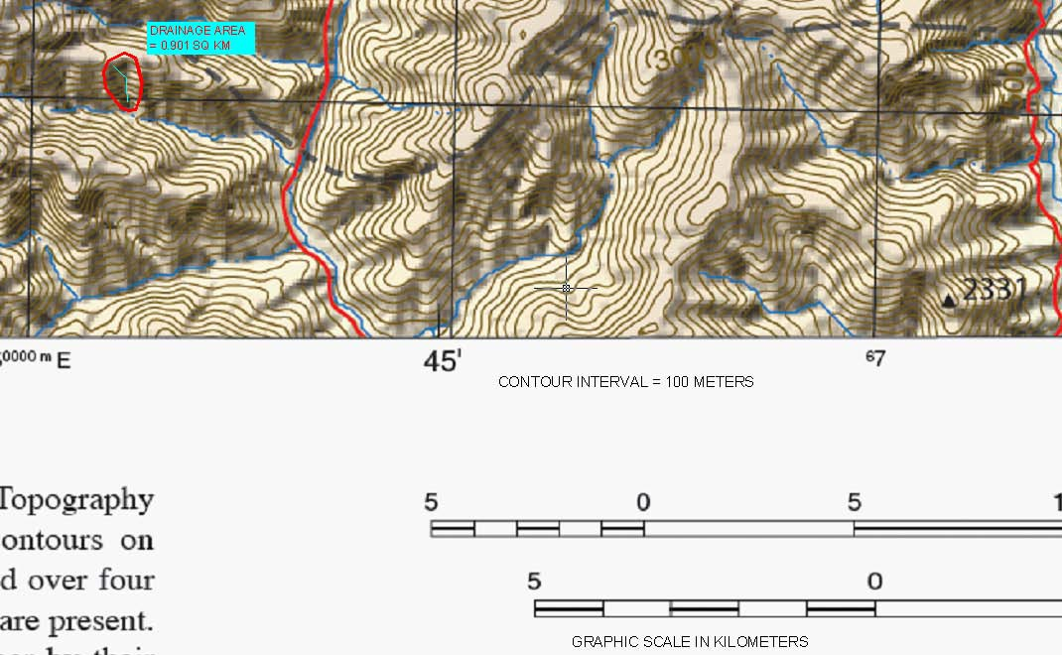

Ground cover map from reference 6:

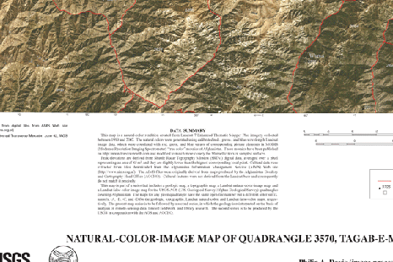

Project site

Jalalabad IDF Chart:

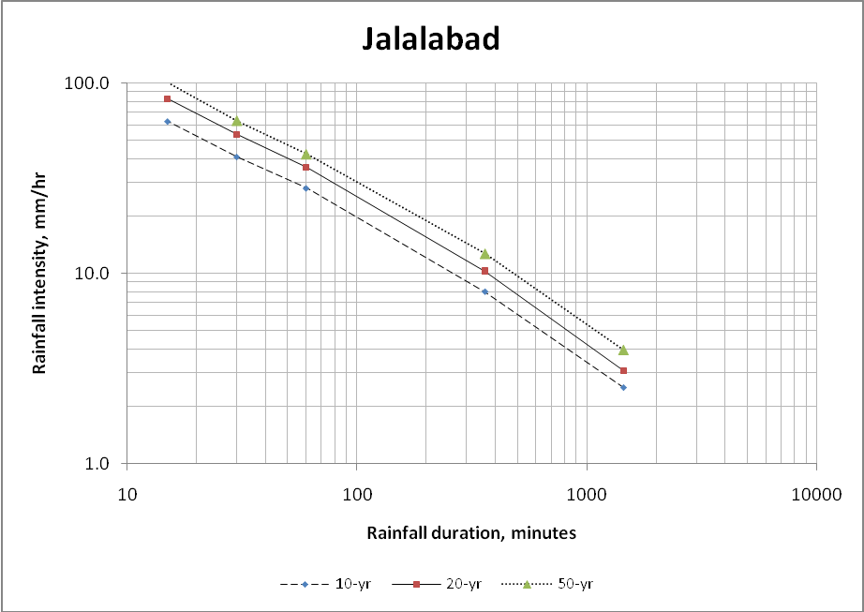

**Based on Topographic Map: Step**

**1 To = Overland flow time for concentration = 0.275*(Lo^0.42)*(So^-0.19)*(C^-1.0)**

|  |  |  |
| --- | --- | --- |
| **So =** | **∆ Elevation =** | **984 Based on map contour over longest flow distance** |
|  | **Ls** | **1,273 Longest length required for flow** |
| **So =** | **0.77** |  |
| **Lo (ft) =** | **492** | **Length of shallow overland flow (Max = 150 m)** |
| **C =** | **0.3** | **Runoff coefficient from Table 1**  **0.3 = coefficient for greater than 10% slope, semi desert** |

**To = 0.275*(492^0.42)*(0.77^-0.19)*(0.3^-1.0) = 13 minutes**

**2 Tc = Unpaved Watercourse flow time of concentration = L/Vavg = L/16.441*(Sc^0.5603)**

|  |  |  |  |
| --- | --- | --- | --- |
| **Sc =** | **∆ Elevation =** | **1,312** | **Based on map contour over longest flow distance** |
| **Sc =** | **Lc**  **0.73** | **1,804** | **Based on map measurement of channel length** |

**Tc =**

**1,804**

**16.441*(0.73^0.5603)**

**= 129 seconds = 2.2 min**

**3 T = Total flow time for concentration / Rainfall Duration (minutes) = To + Tc = 13 min + 2 min = 15 minutes**

**4 Drainage Area = 0.901 km2**

**5 Ten year storm rainfall intensity = Based on Area Rainfall Intensity Hydrograph**

**I = 62.0 mm/hr**

**6 Q = Flow at time of concentration (ratinoal method) = Q = 0.278*C*A*I Q = 0.278*.3*0.901*14.0 = 4.65 m3 / sec**

**Appendix B Intensity-Duration-Frequency Curves for Selected Project Regions**

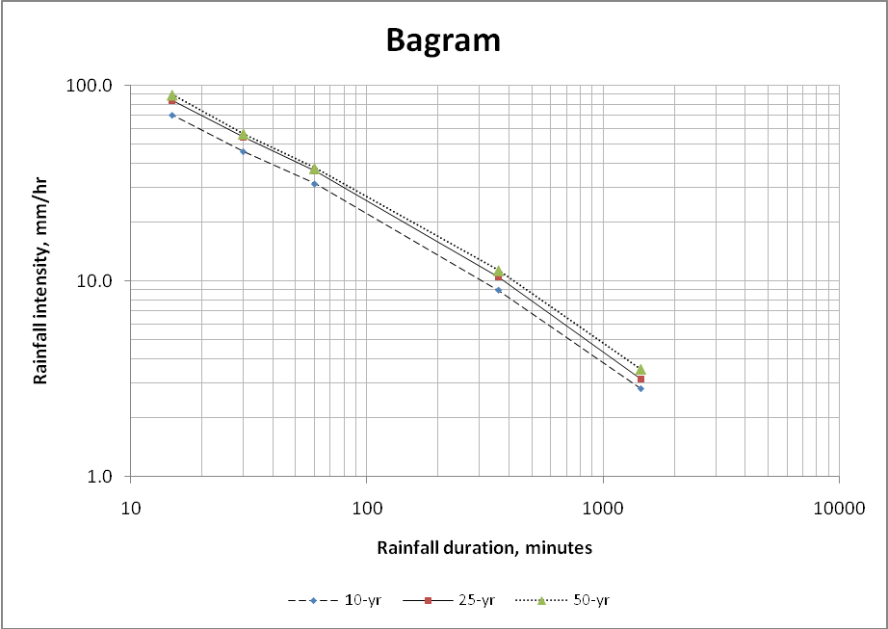

100.0

**Kabul**

10.0

**Rainfall intensity, mm/hr**

1.0

10 100 1000 10000

**Rainfall duration, minutes**

10-yr 20-yr

50-yr



100.0

**Gardez**

10.0

**Rainfall intensity, mm/hr**

1.0

10 100 1000 10000

**Rainfall duration, minutes**

10-yr 20-yr

50-yr

100.0

**Ghazni**

10.0

**Rainfall intensity, mm/hr**

1.0

10 100 1000 10000

**Rainfall duration, minutes**

10-yr 20-yr

50-yr

100.0

**Kunar IDF**

10.0

**Rainfall intensity, mm/hr**

1.0

10 100 1000 10000

**Rainfall duration, minutes**

10-yr 20-yr

50-yr

100.0

**Farah IDF**

10.0

**Rainfall intensity, mm/hr**

1.0

10 100 1000 10000

**Rainfall duration, minutes**

10-yr 20-yr

50-yr

100.0

**Herat IDF**

10.0

**Rainfall intensity, mm/hr**

1.0

10 100 1000 10000

**Rainfall duration, minutes**

10-yr 20-yr

50-yr

100.0

**Baghlan/Kunduz**

10.0

**Rainfall intensity, mm/hr**

1.0

1 10 100 1000 10000

**Rainfall duration, minutes**

10-yr 20-yr

50-yr

**NOTE:**

**If rainfall data for a 10-year storm event is not available within a particular project site area, a value of 50mm/hr shall be used in calculating design flows.**

**Appendix C Area Factor for Point Rainfall Reduction Curves**

0

100

48 97

145

Area (mi2 )

193

241 290

338

386

"' 90

r----- 24-Lur

\\

----

6-hour

c

*v*

.:::.

Oil

'-

80

.£

._

"'

**.5**

"'- '

;::

70

·s

._.

0

---------

...

-----

----

\

----

!-hour

3-hour

0

'-

p"..

60 inutes

50

0 125 250 375 500

Area (km 2)

625 750 875 1000

FIGURE **14.1.3**

Depth-area curves for reducing point rainfall to obtain areal average values. *(Source:* World Meteo·

rological Organization, 1983: originally published in Technical Paper 29, U. S. Weather Bureau,

1958.)